# HAD

# WEB APP NAMED- CONNECT

# FRONTEND WILL BE CONSISTING -HTML,CSS ,JS and ANGULAR JS

# BACKEND WILL BE CONSISTING – JAVASCRIPT,PHP,FIREBASE

DHRUV RATHOD 3023

SOHEL SUNESRA 3040

MEHRAJ KHORAJIA 3097

MEHRAJ KHORAJIA 309



websites and applications that enable users to

create and share content or to participate in social

networking.



LOGIN PAGE

Login page consisting of basic 2 field i.e username and password

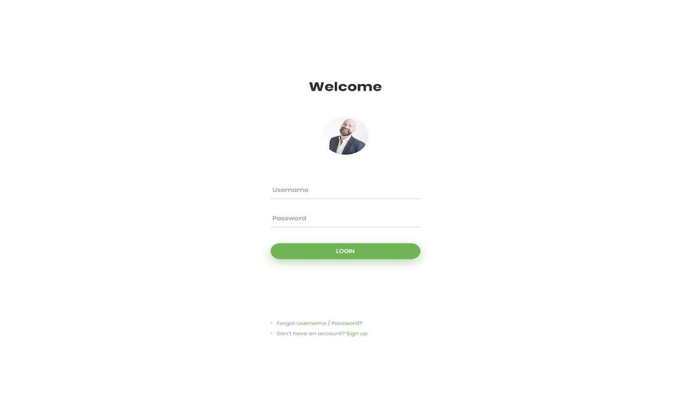The **login page** allows a user to gain access to an application by entering their username and password or by authenticating using a social media **login**.



.

|  |
| --- |
| 3 |
|  |

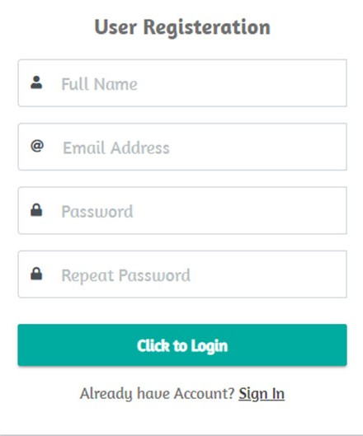Sign up page



Sign up page

Full name

Email address

Password

Repeat password



FORGET PASSWORD PAGE

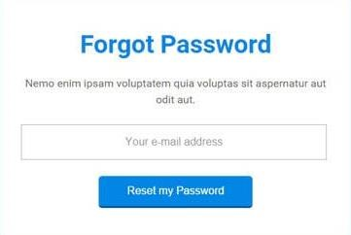

RESET PASSWORD

**Reset password**

is the action

of invalidating the

current

**password**

for an

account on a website, service,

or device, and then creating a

new one. A

**password**

may

be

**reset**

using the settings of

the software or service



PROFILE PAGE OF USER

A user

**profile**

is a visual display of personal

data associated with a specific user.

A

**profile**

refers to the explicit digital

representation of a person's identity.

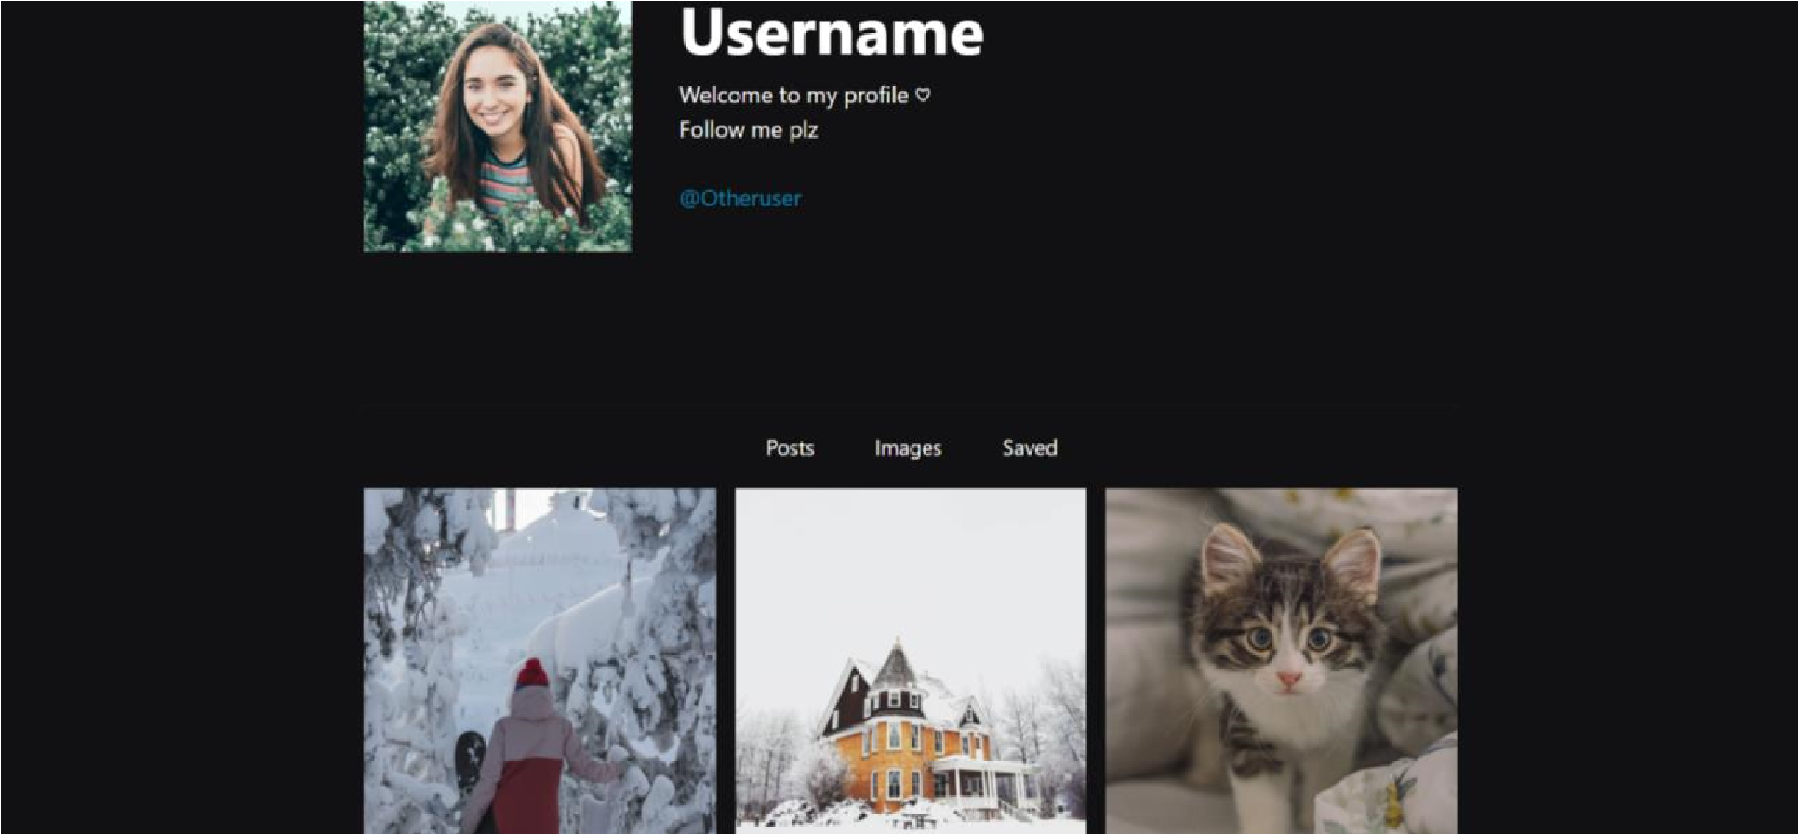

# FOR BACKEND WILL BE USING PHP JAVASCRIPT AND FIREBASE

# A Real time Messaging System where messages form one user to another user are being passed

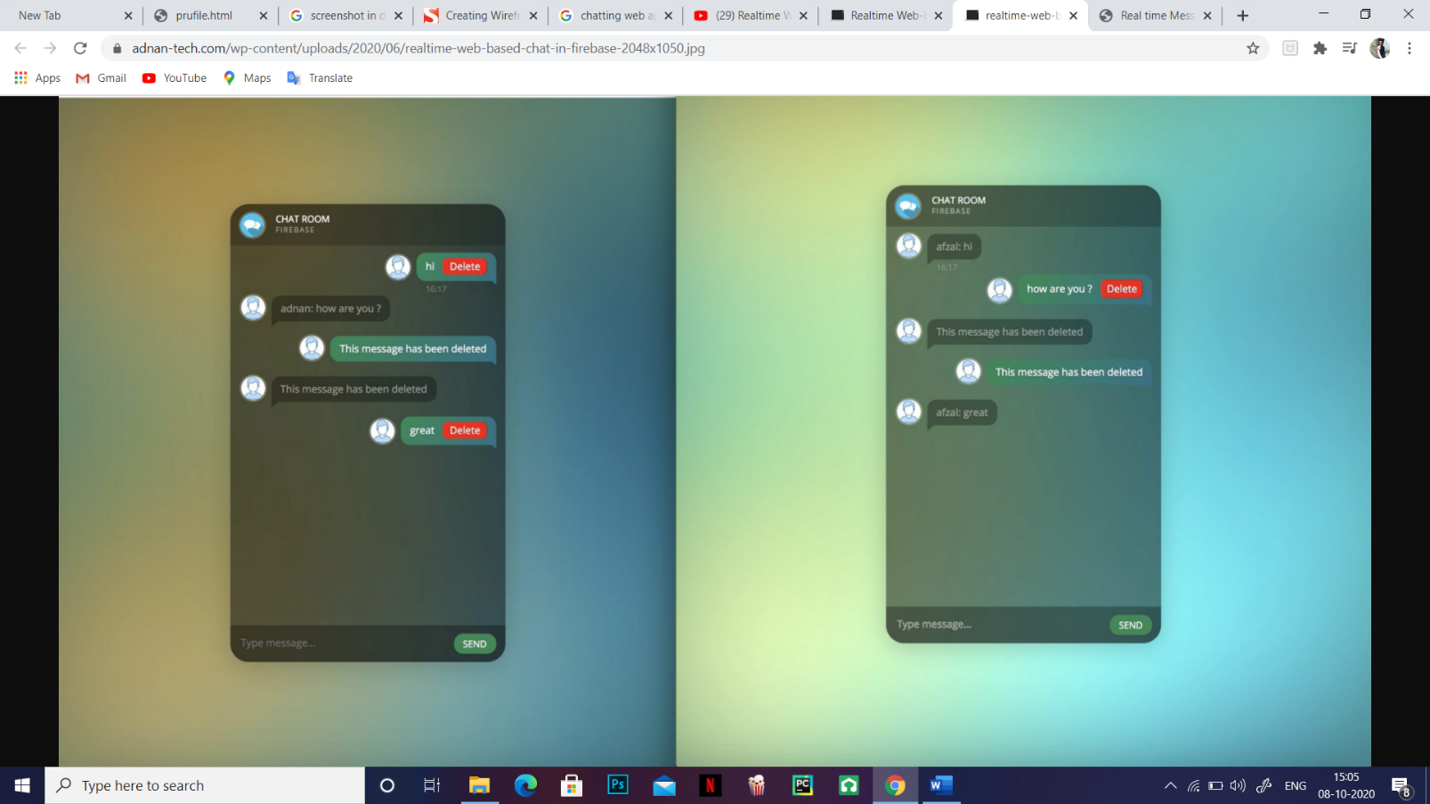

# THANK YOUUUUUUUUU!!!

# 